HILLY FIELDS FOOTBALL CLUB
SEASON 22: 1988-89
Beckenham League Veterans Cup
P W D L F A
Courage Vets 1 0 0 1 1 5

Apps Gls
Adrian Bennett 1 0
Steve Chitty 1 0
Tony Emerson 1 0
John Felton 1 0
Keith Foster 1 0
Len Franklin 1 0
John Macrea 1 0
Ray Griffin 1 0
Malcolm Hill 1 0
Ralph Stanton 1 1

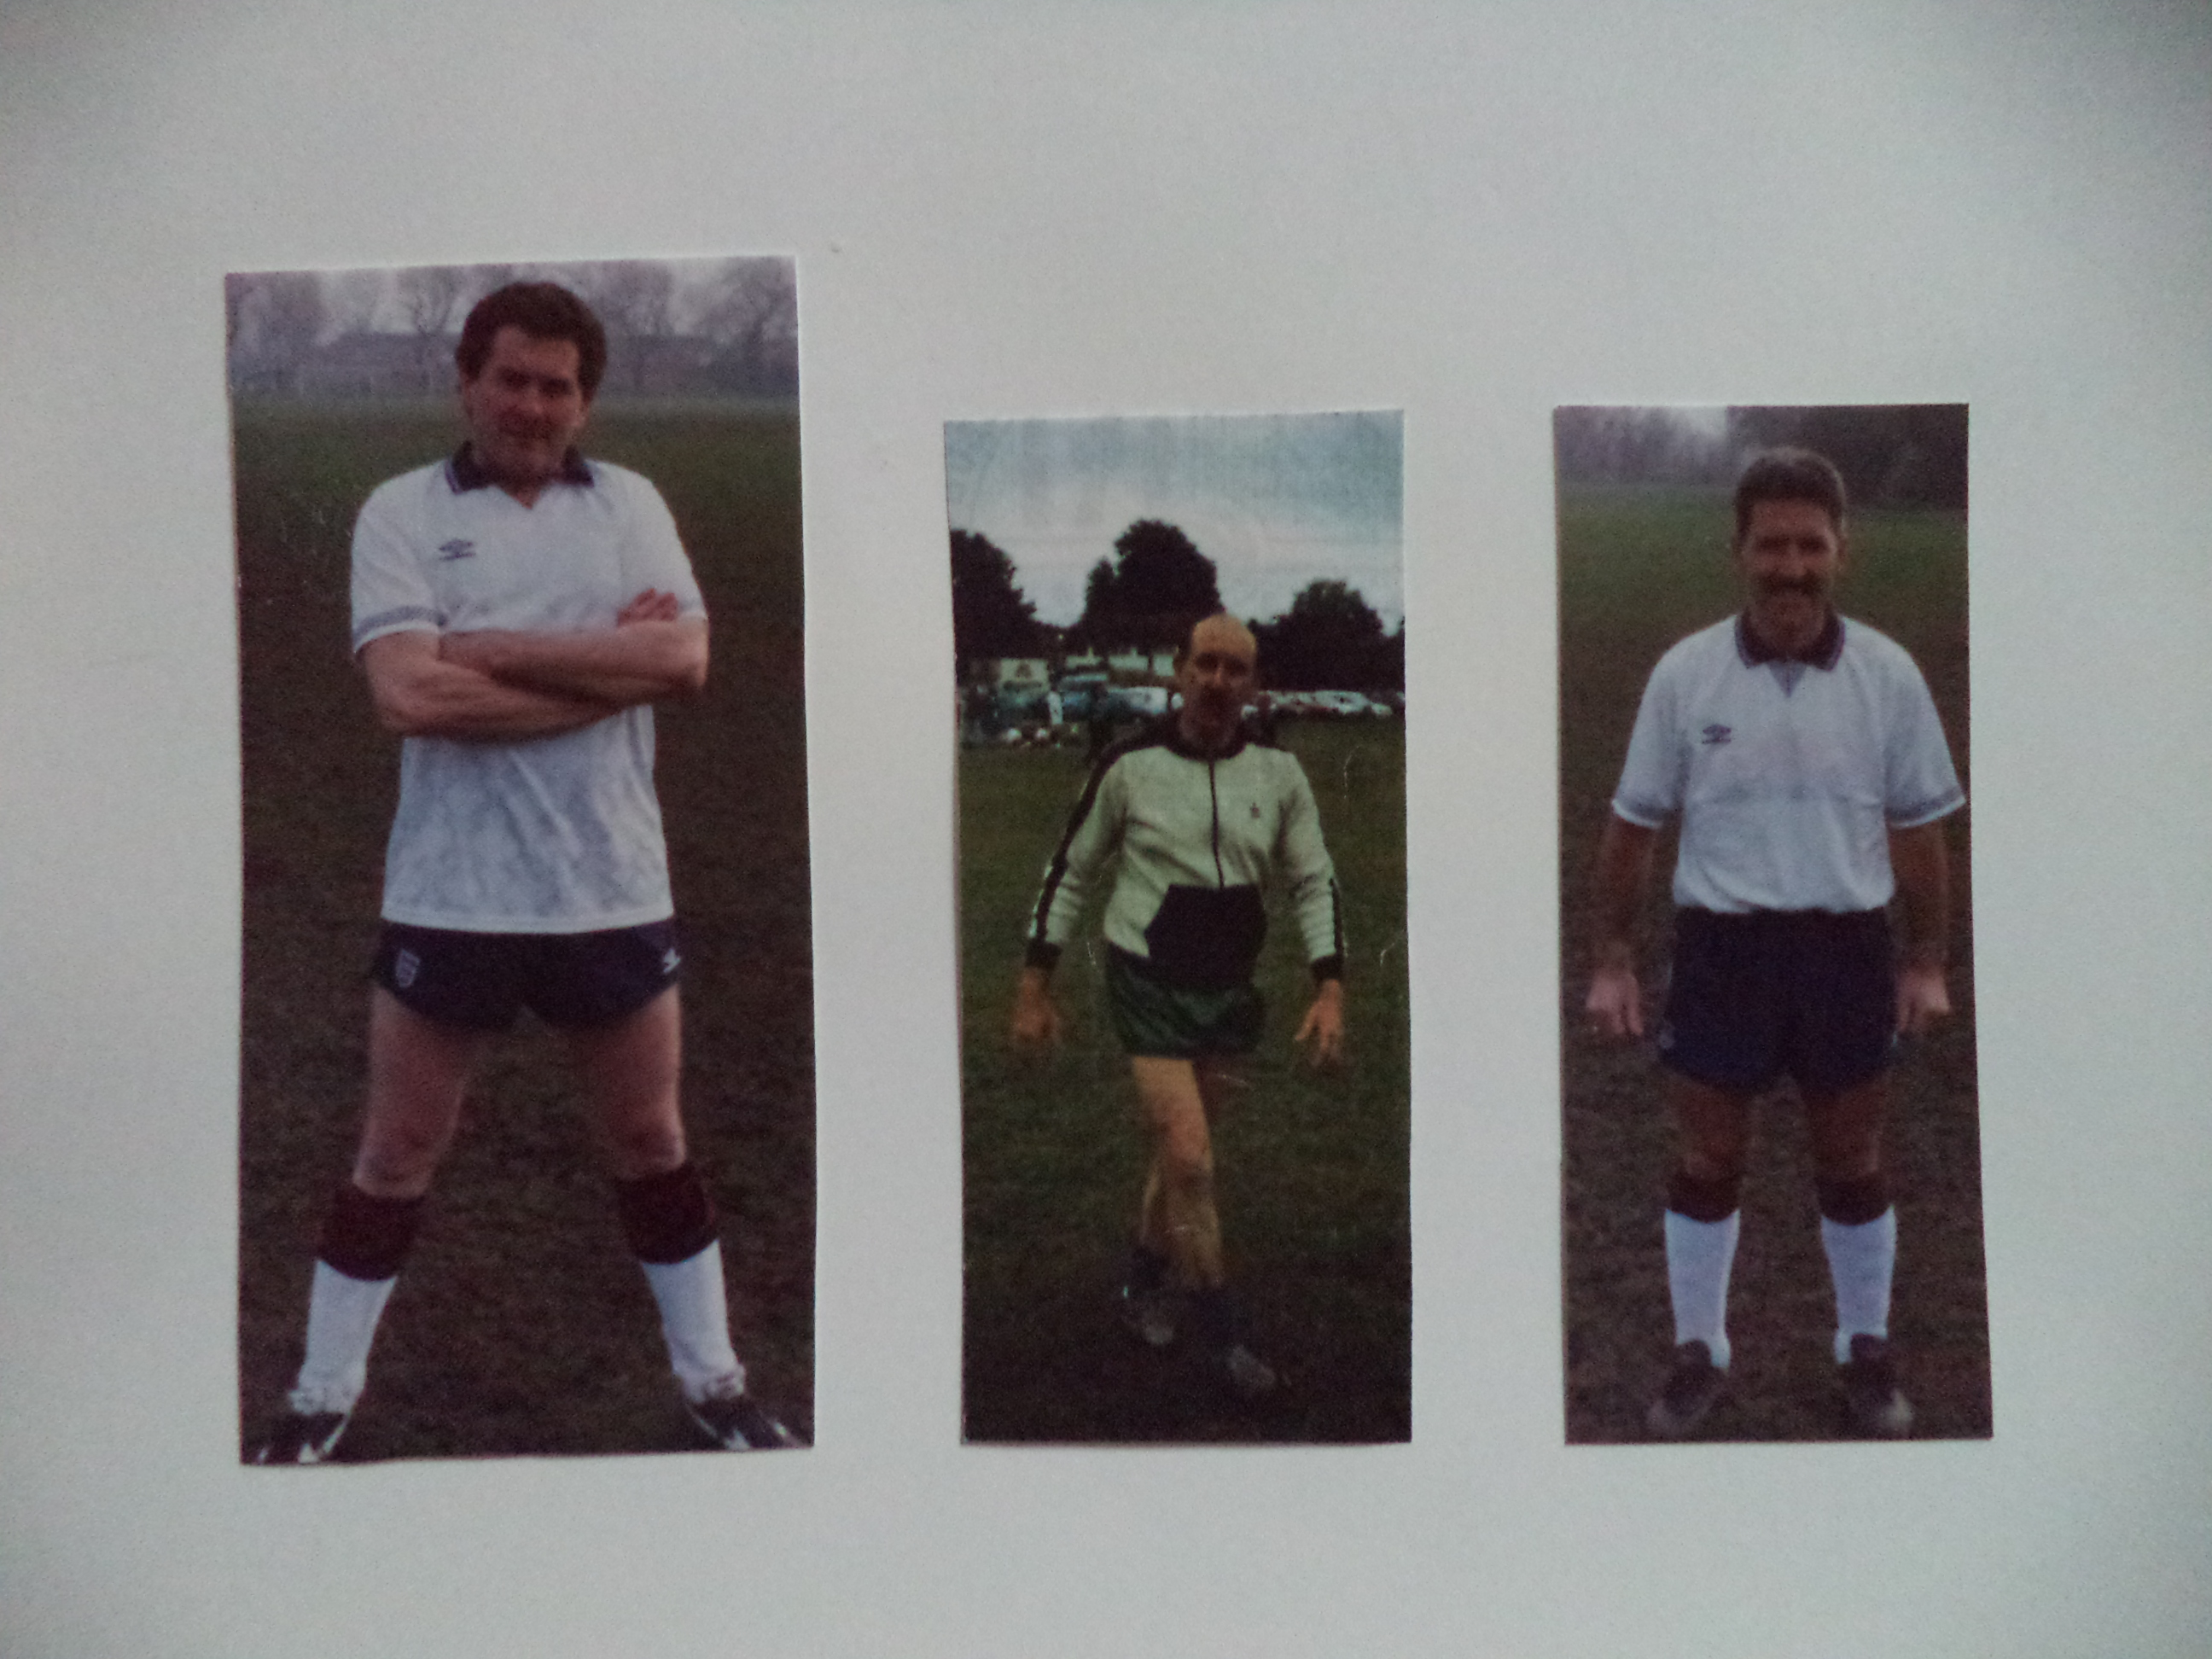
Len Franklin John McCrea Ralph Stanton

